Multi Choice Answers Task 6: Test – Variation, Mutation and Evolution (10 marks)

- Mutations that occur in body cells are called
- germline

somatic
- gene
- autosomal

- Genetic traits that are determined by two or more pairs of genes are

- multi-allelic.
- co-dominance.

polygenic
- incomplete dominance

- Skin colour is affected by

exposure to ultra violet light and genotype
- exposure to infra-red light and phenotype
- just genotype
- just environmental factors

- Thalassemia results in

having anaemia with high iron levels

  - having anaemia with low iron levels

  - the need for iron tablets to supplement iron reserves

  - a dominant disease resulting in defects in haemoglobin formation

- Populations that have become genetically isolated from one another

- usually have the same gene frequencies for physical characteristics
- are not subject to random genetic drift
- are subject to similar environmental selection pressures

may develop into different subspecies that are unable to interbreed

- A mutation is a sudden change in the structure of a gene. Scientists link mutations to the process of natural selection very closely. Mutations

- always produce beneficial variations upon which natural selection can act

are of importance to natural selection only if they can pass from generation to generation
- will improve the survival chances of an individual
- result in random genetic drift

- Tay-Sachs Disease is a hereditary disorder of

lipid metabolism
- protein metabolism
- carbohydrate metabolism
- vitamin D synthesis

- Humans throughout the world are considered by scientists to belong to a single species because they all

- make use of manufactured tools

can interbreed to produce offspring
- have binocular colour vision
- use language and symbols as a means of cultural transmission

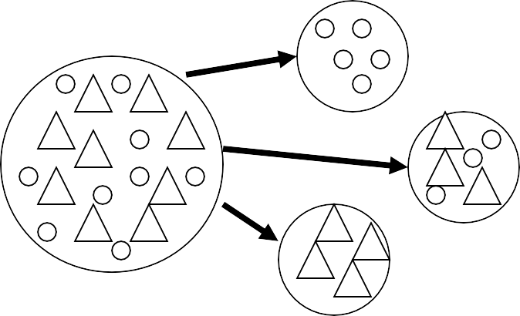
- These diagrams below indicate

- migration

founder effect
- genetic drift
- geographical barrier

- Which best describes the genotype for sickle cell anaemia?

- H^{A}H^{S}
- hh

H^{S}H^{S}

Hh

